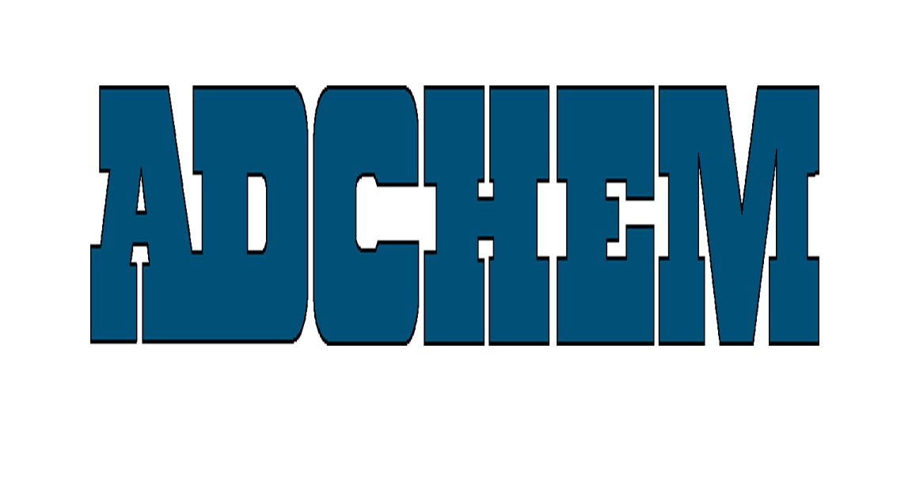

For Immediate Release:

Adchem Achieves Automotive Specification Re-Certification

Adchem Corporation, a leading manufacturer of high performance film and foam bonding adhesive tapes, has completed their annual automotive certification testing. Using their A2LA accredited facility, Adchem has tested and re-certified numerous double-coated, transfer tape, and foam tape products to specifications from several OEM and Tier One Automotive Suppliers. The 7-page document is available both in hard copy and electronically.

Adchem’s innovative line of double-coated, single-coated and transfer tape adhesive tape systems, coupled with its advanced engineering capabilities, enables Adchem to develop solutions for the most demanding industrial and automotive applications. Adchem provides automotive tapes for interior, under-carriage and under-hood bonding requirements supporting a global network of tier 1 and 2 suppliers, as well as leading fabricator converters.

About Adchem Corporation
Adchem, an ISO 9001 certified and A2LA accredited company, manufactures an innovative line of pressure-sensitive adhesive tape systems, including double-coated papers, films, tissues, foams and fabrics; transfer tapes; one-side coated products and other custom-coated specialty products. Our 100% solids adhesives, solvent and water based acrylics and rubber adhesives are used in a variety of industries, including automotive, construction, electronics, graphic arts, medical and general industrial tape applications.
For additional information, please contact Adchem Corporation, 1852 Old Country Road, Riverhead, NY 11901 Phone: (631) 727-6000 Fax: (631) 727-6010 or our website at www.adchem.com .

